

SUN ODYSSEY 33i

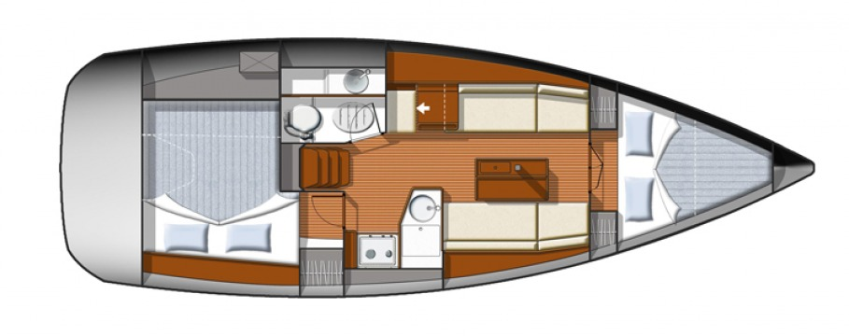

YEAR 2010/2014

Length overall 9,96 m | Cabins 2
Beam 3,34 m | Berth 4+2
Displacement 4645 kg | Draft 1,50 m
Water capacity 160 l | Engine Yanmar 20 HP
Fuel capacity 140 l | Sail area 43 m²
EQUIPMENT  - Tender  - Hot water  - Cockpit table  - Roll main sail and roll genoa  - Elecrtic windlass  - Bimini top  - Sprayhood | ELECTRICAL EQUIPMENT  - GPS with plotter on captains table  - GPS with plotter in cockpit  - Autopilot  - Speed and echo log  - VHF  - Radio-CD player  - Wind instrument
OUTSIDE  - 2 winch handles  - 2 anchors with chain  - ropes  - 6 fenders  - boat hook  - wind direction indicator  - life bouy  - 2 gas bottles  - byboat pump  - water nose + brush  - bilge pump + handle | INSIDE  - charts  - plotters + divider  - hand bearing compass  - binoculars  - pilot books  - life jackets  - first aid kit  - portable lamp  - tools  - clock + barometer  - kitchen equipment

